ASSIGNMENT NO:-01

create schema assignment;

use assignment;

create table employees (id int,name varchar(20),position varchar(20),salary int);

insert into employees values(1,"John","HR",50000);

select * from employees;

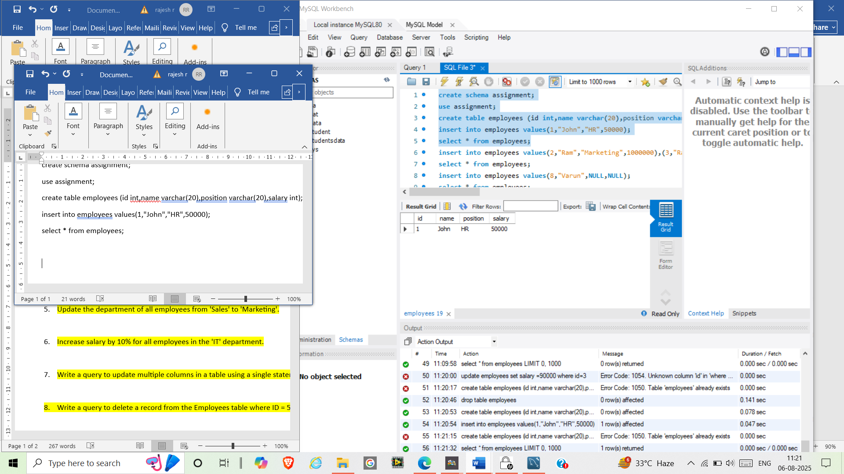

insert into employees values(2,"Ram","Marketing",1000000),(3,"Rani","Sales",60000),(4,"Raja","IT",70000),(5,"Rahul","Marketing",900000),(6,"Roja","Sales",600000),(7,"Lily","IT",7000000);

select * from employees;

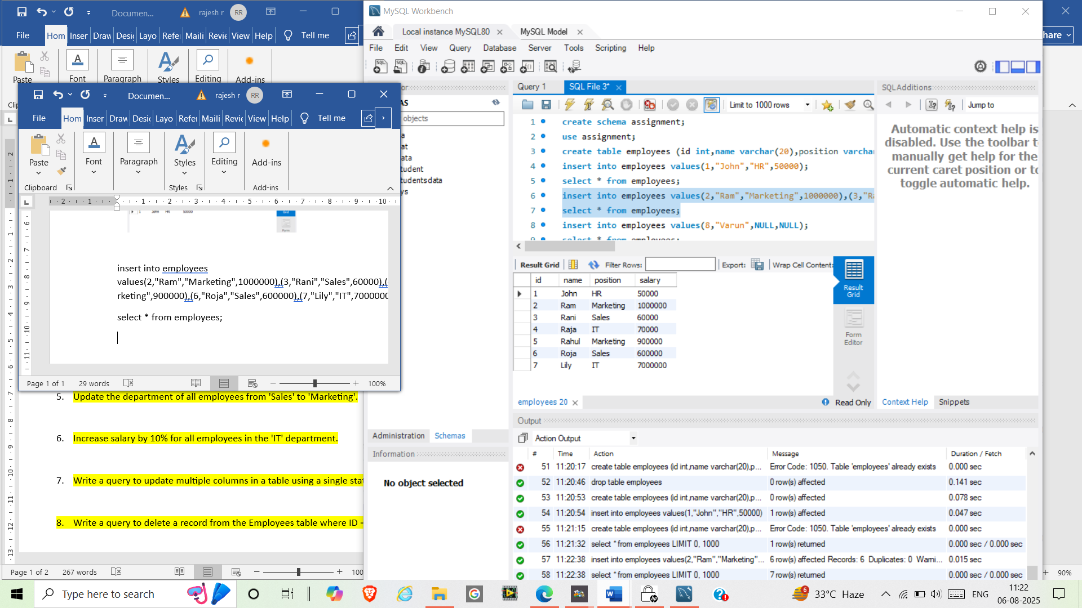

insert into employees values(8,"Varun",NULL,NULL);

select * from employees;

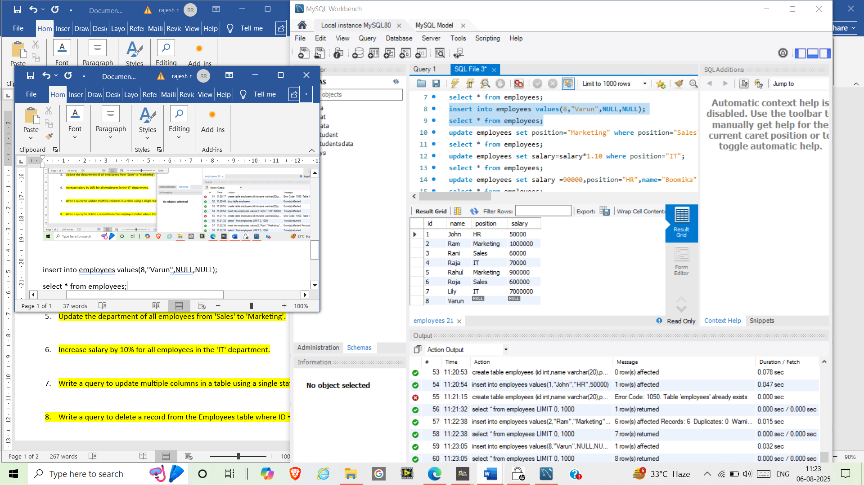

update employees set salary =90000 where id=3;

select * from employees;

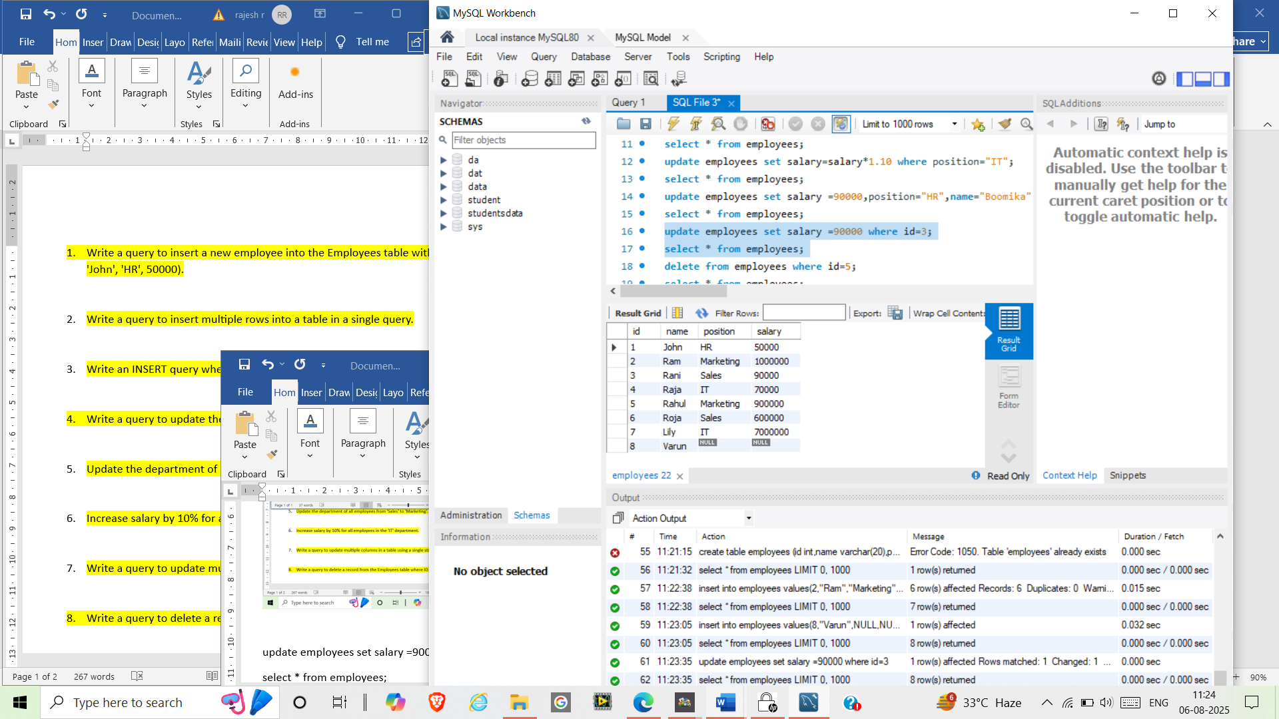

update employees set position="Marketing" where position="Sales";

select * from employees;

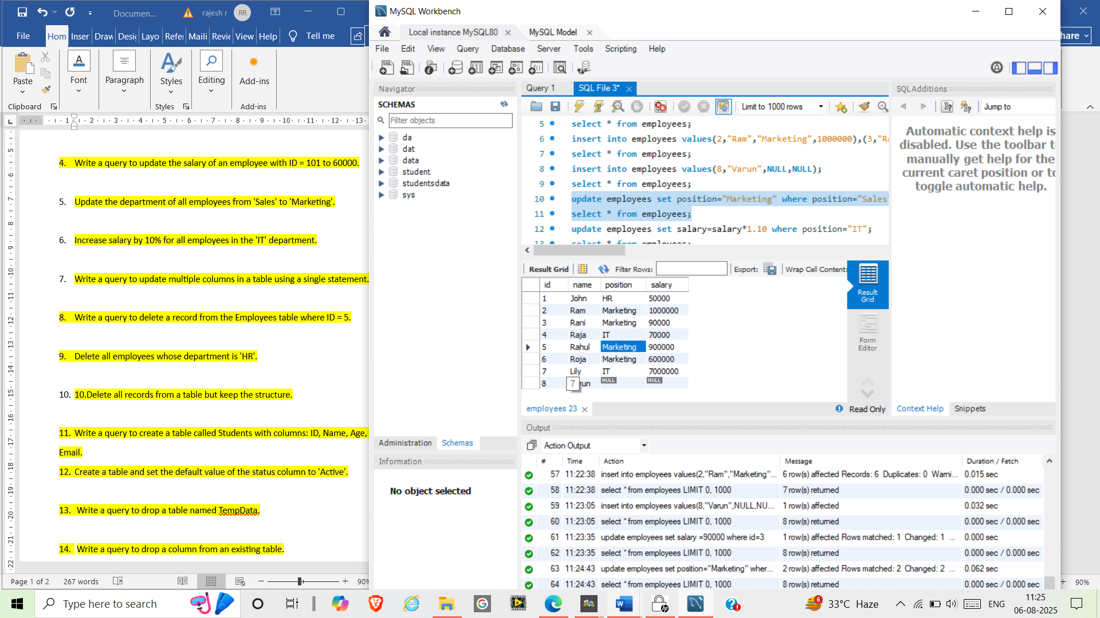

update employees set salary=salary*1.10 where position="IT";

select * from employees;

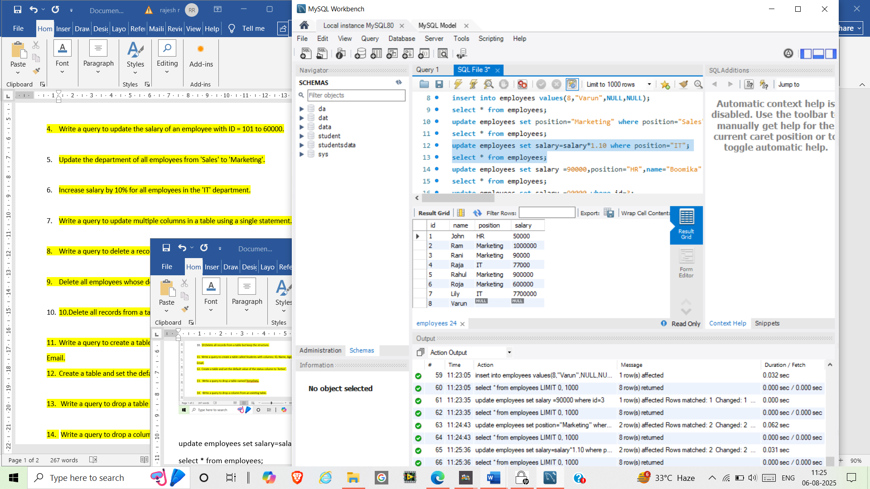

update employees set salary =90000,position="HR",name="Boomika" where id=1;

select * from employees;

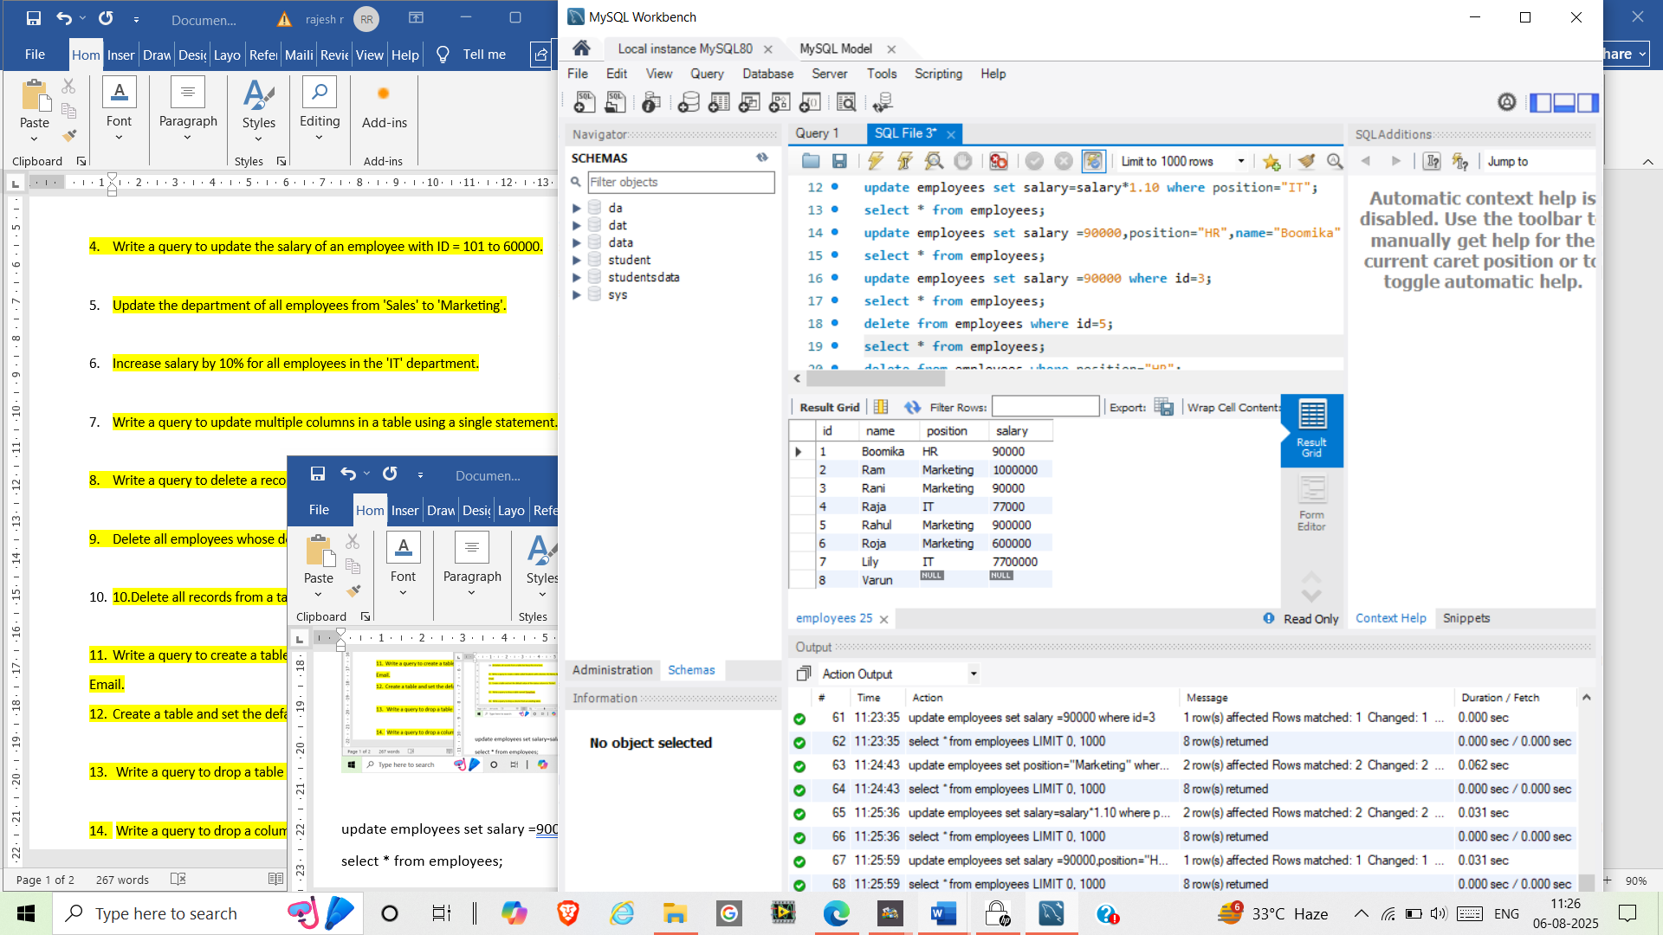

delete from employees where id=5;

select * from employees;

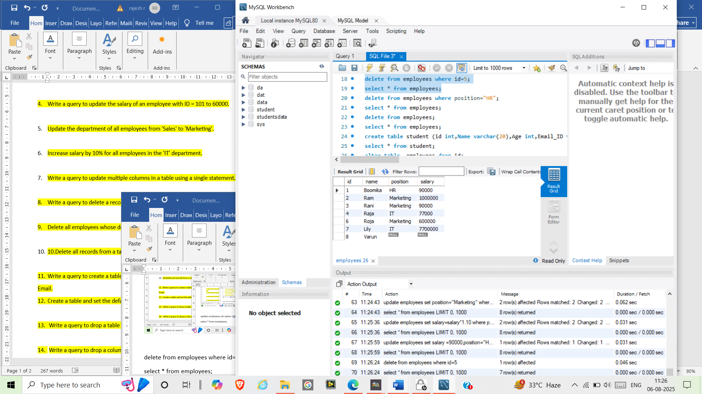

delete from employees where position="HR";

select * from employees;

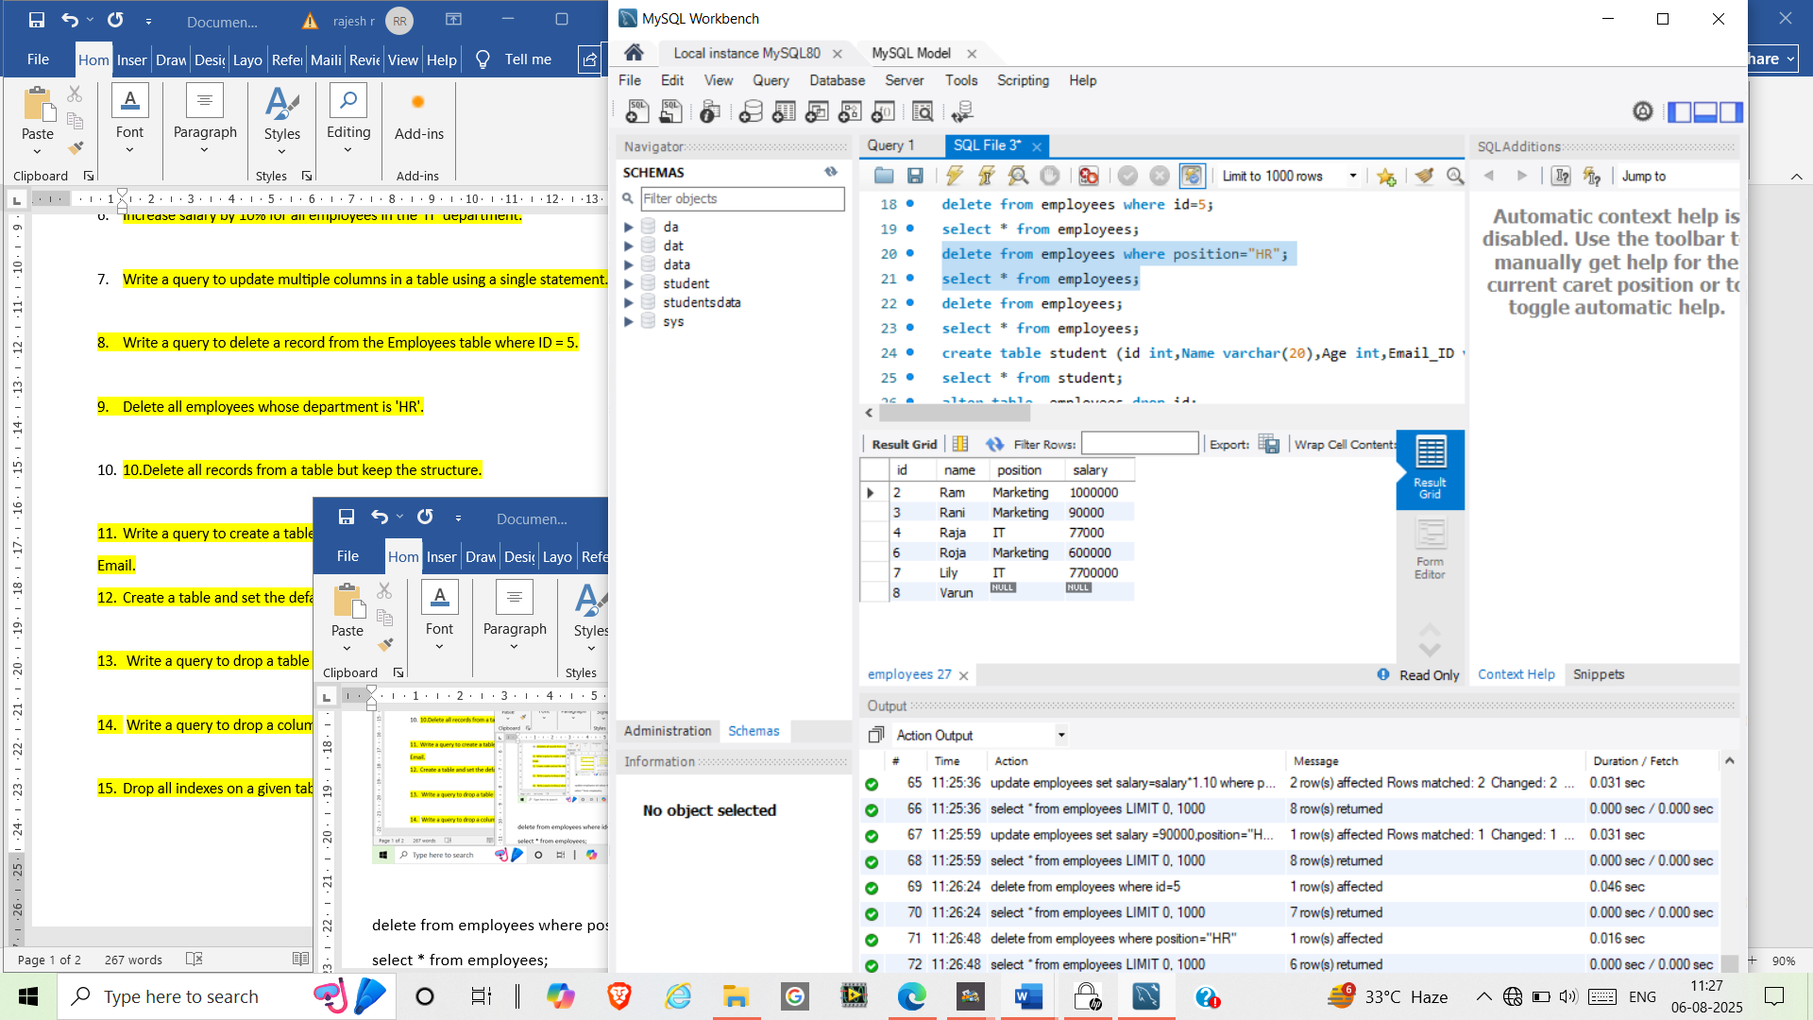

delete from employees;

select * from employees;

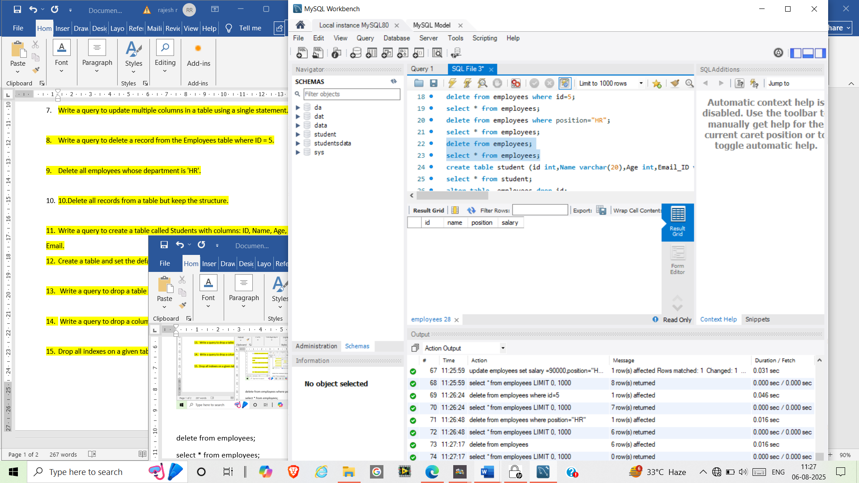

create table student (id int,Name varchar(20),Age int,Email_ID varchar(20));

select * from student;

create table temp_Data (id int,month varchar(20),status varchar(20) default "Active");

insert into temp_Data values(1,"Jan",default),(2,"Feb",default);

select*from temp_Data;

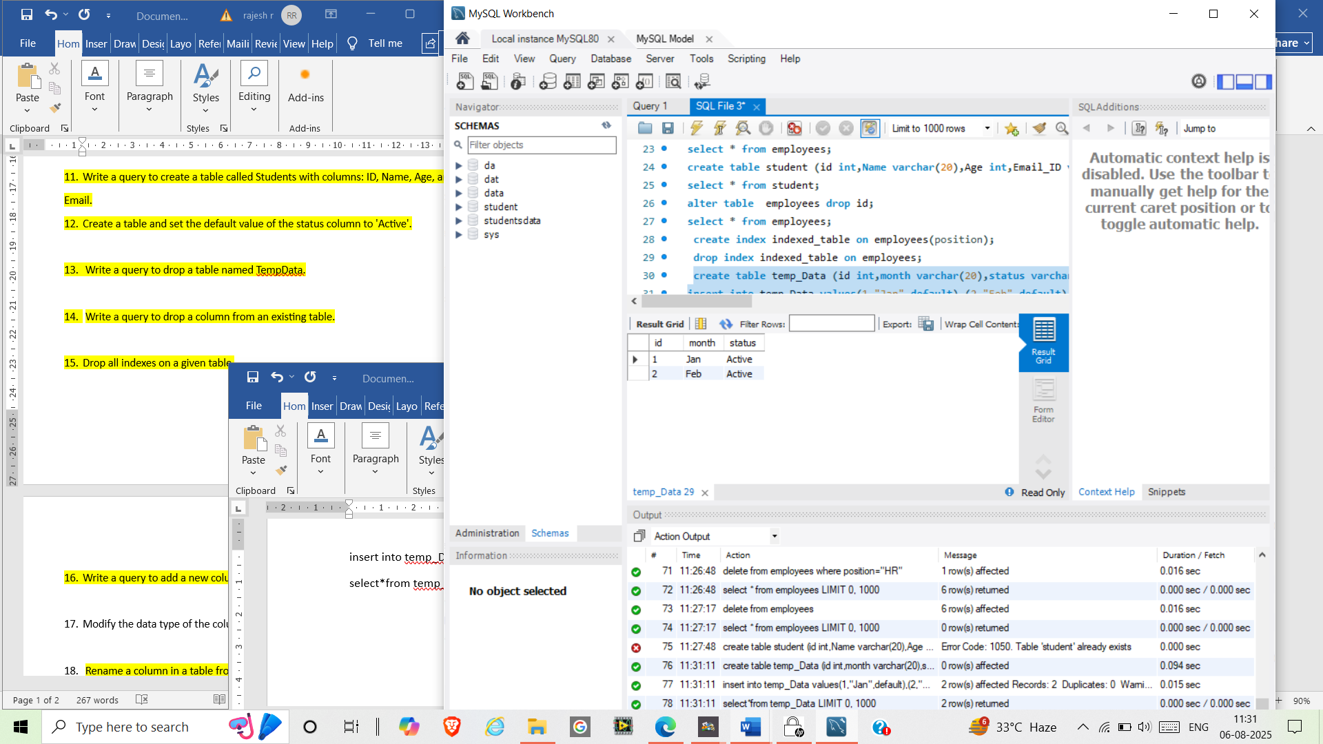

drop table temp_data;

alter table employees drop id;

select * from employees;

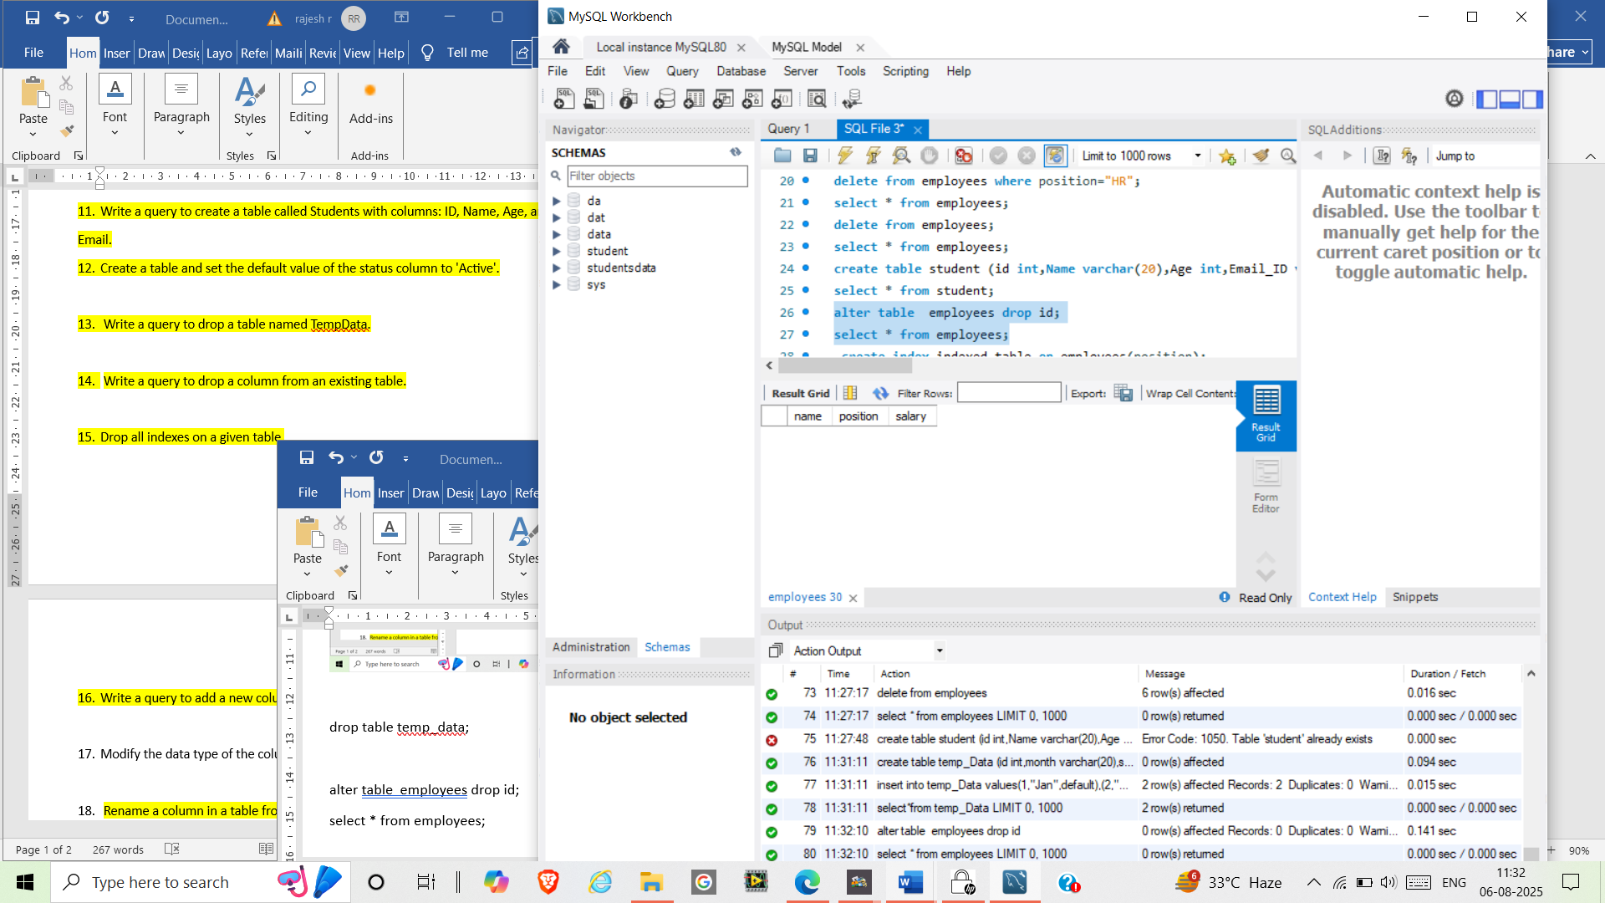

create index indexed_table on employees(position);

drop index indexed_table on employees;

alter table employees add DOB date;

select* from employees;

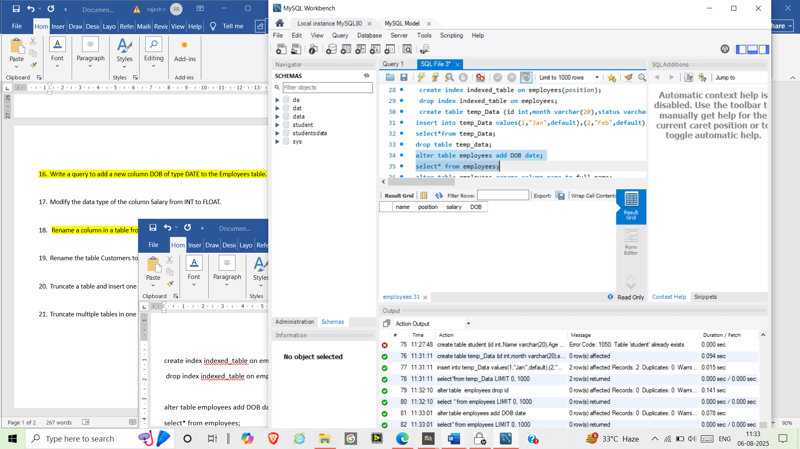

alter table employees rename column name to full_name;

select * from employees;

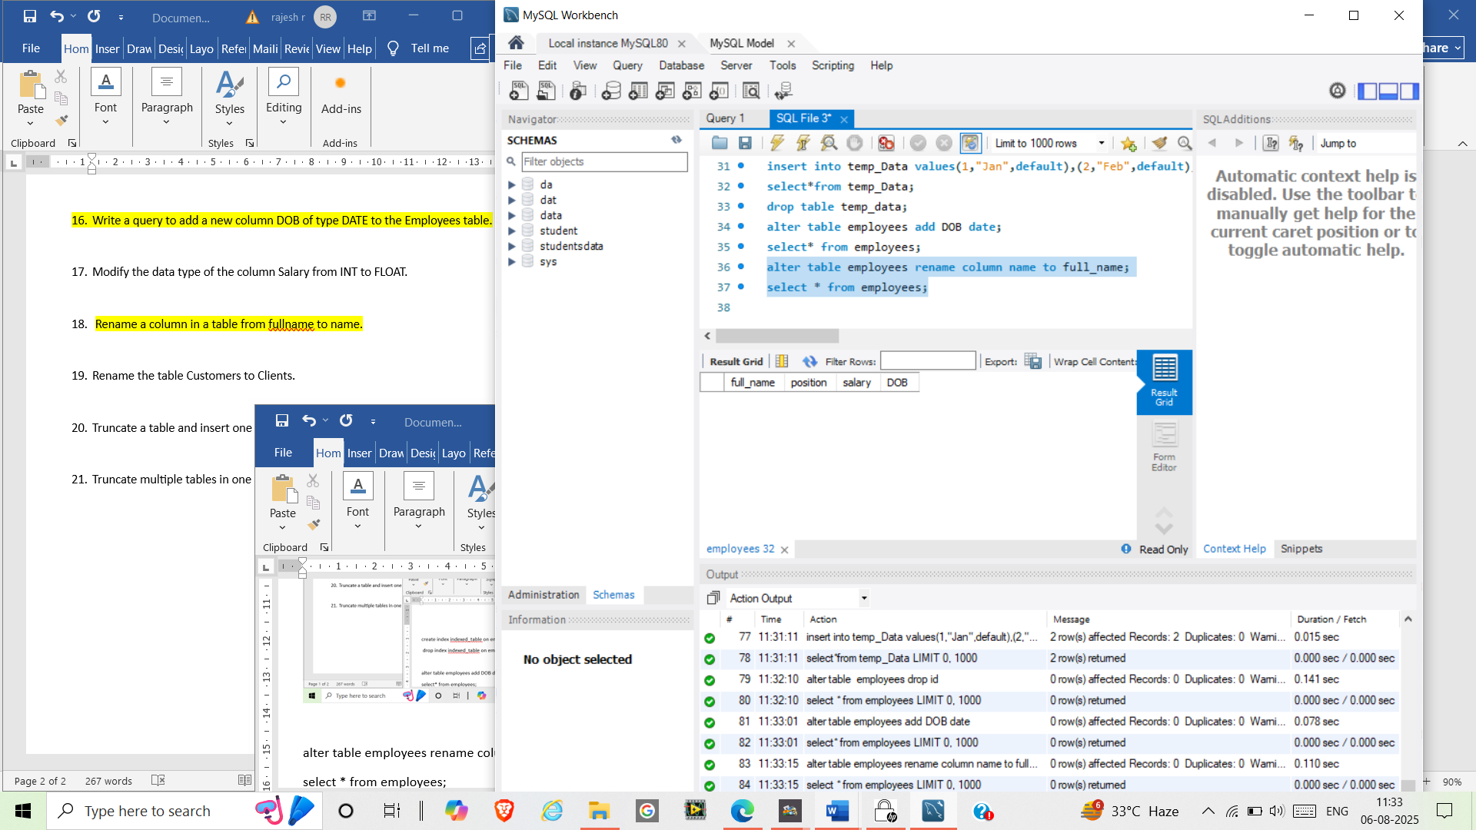

alter table employees modify Salary FLOAT;

select * from employees;

rename table employees to clients;

select*from clients;

truncate table clients;

insert into clients (salary) values (100000);

select*from clients;